

Southern Luzon State University
COLLEGE OF ENGINEERING
Computer Engineering Department
Lucban, Quezon

CPE22L: Digital Signal Processing Laboratory

Activity # 8: FIR and IIR Filters Design

PADUADA, Dave Jhared G.

DOP: Nov 26, 2025
DOS: Dec 3, 2025

RATING

Engr. Ralph Monsour Delima
INSTRUCTOR

- Objectives
  - To learn the different methods of designing the Finite Impulse Response (FIR), and Infinite Impulse Response (IIR) Filters.
  - To determine the MATLAB codes used to design filters
  - To understand the importance and significance of filters in digital signal processing.
- Introductory Information

Filters are a basic component of all signal processing and telecommunication system. A filter is a device or process that removes some unwanted components or features from a signal. Filtering is a class of signal processing used to complete or partial suppression of some aspects of the signal. Most often, this means to remove some frequencies and not others in order to suppress the interfacing signals and reduce the background noise.

- Data & Procedures

Exercises 8.1.  FIR Lowpass Filter Using fir1() Function:  %Program 8_1 FIR_Lowpass  %A MATLAB program to design FIR Lowpass Filter using MATLAB  %function fir1().  clf; %Clear all figures  clear all; %Clear all variables  close all; %Close all figures  N = 512;  O = 64; %Define the order of the filter  fc = input('Enter the cutoff frequency: ');  fs = input('Enter the sampling frequency: ');  Wc=2*fc/fs; %Normalizing the frequencies  b=fir1(O,Wc,'low'); %Calculation of filter coefficients  freqz(b,1,N,fs); %Plotting the filter response  title('Magnitude and Phase Response of FIR Lowpass Filter'); | Exercise 8.2  FIR Highpass Filter Using fir1() Function:  %Program 8_2_FIR_Highpass  %A MATLAB program to design FIR Highpass Filter using MATLAB  %function fir1().  clf; %Clear all figures  clear all; %Clear all variables  close all; %Close all figures  N = 512;  O = 64; %Define the order of the filter  fc = input('Enter the cutoff frequency: ');  fs = input('Enter the sampling frequency: ');  Wc=2*fc/fs; %Normalizing the frequencies  b=fir1(O,Wc,'high'); %Calculation of filter coefficients  freqz(b,1,N,fs); %Plotting the filter response  title('Magnitude and Phase Response of FIR Highpass Filter');
FIR Bandpass Filter Using fir1() Function:  %Program 8_3: FIR_Bandpass  %A MATLAB program to design FIR Bandpass Filter using MATLAB  %function fir1().  clf; %Clear all figures  clear all; %Clear all variables  close all; %Close all figures  N = 512;  O = 64; %Define the order of the filter  fn =input('Enter the passband range of frequencies: ');  fs = input('Enter the sampling frequency: ');  Wn=2*fn/fs; %Normalizing the frequencies  b=fir1(O,Wn); %Calculation of filter coefficients  freqz(b,1,N,fs); %Plotting the filter response  title('Magnitude and Phase Response of Bandpass Filter'); | FIR Bandstop Filter Using fir1() Function:  %Program 8_4 FIR_Bandstop  %A MATLAB program to design FIR Bandstop Filter using MATLAB  %function fir1().  clf; %Clear all figures  clear all; %Clear all variables  close all; %Close all figures  N = 512;  O = 64; %Define the order of the filter  fn = input('Enter the stopband range of frequencies: ');  fs = input('Enter the sampling frequency: ');  Wn=2*fn/fs; %Normalizing the frequencies  b=fir1(O,Wn,'stop'); %Calculation of filter coefficients  freqz(b,1,N,fs); %Plotting the filter response  title('Magnitude and Phase response');
IIR Butterworth Lowpass Filter:  % Program 8_5 IIR_Butterworth_Lowpass  %A MATLAB program to design IIR Butterworth Lowpass Filter  clf; %Clear all figures  clear all; %Clear all variables  close all; %Close all figures  N = 512;  n = 6; %Define the order of the filter  fc = input('Enter the cutoff frequency: ');  fs = input('Enter the sampling frequency: ');  Wc = 2 * fc / fs; %Normalizing the frequencies  [b,a]=butter(n,Wc,'low'); %Calculation of filter coefficients  freqz(b,a,N,fs); %Plotting the filter response  title('Magnitude and Phase response of Butterworth IIR Lowpass filter'); | IIR Chebyshev-Type-1 Lowpass Filter:  %Program 8_6 IIR_Chebyshev_Type_1_Lowpass  %A MATLAB program to design IIR Butterworth Lowpass Filter  clf; %Clear all figures  clear all; %Clear all variables  close all; %Close all figures  N = 512;  n = 6; %Define the order of the filter  rp = 0.5; %Define the Passband peak-to-peak ripple in decibels  fc = input('Enter the cutoff frequency: ');  fs = input('Enter the sampling frequency: ');  Wc = 2 * fc / fs; %Normalizing the frequencies  [b,a]=cheby1(n,rp,Wc,'low'); %Calculating filter coefficients  freqz(b,a,N,fs); %Plotting the filter response  title('Magnitude and Phase Response of Chebyshev-Type-1 IIR Lowpass Filter');
IIR Chebyshev-Type-2 Lowpass Filter:
%Program 8_7 IIR_Chebyshev_Type_2_Lowpass
%A MATLAB program to design IIR Butterworth Lowpass Filter
clf; %Clear all figures
clear all; %Clear all variables
close all; %Close all figures
N = 512;
n = 6; %Define the order of the filter
R = 20; %Stopband ripple in decibles
fc = input('Enter the cutoff frequency: ');
fs = input('Enter the sampling frequency: ');
Wc = 2 * fc / fs; %Normalizing the frequencies
[b,a]=cheby2(n,R,Wc,'low');%Calculation of filter coefficients
freqz(b,a,N,fs); %Plotting the filter response
title('Magnitude and Phase Response of Chebyshev-Type-2 IIR Lowpass Filter');

- Data and Results
8.1 Run program 8_1 and use the following frequency:  cutoff frequency = 1200 ; sampling frequency = 3000 | 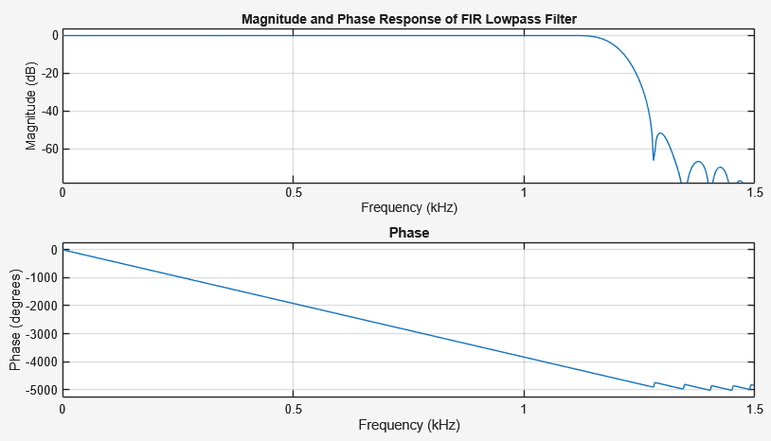  In this activity, a lowpass filter using the fir1 function. This function uses the "window method" (defaulting to a Hamming window) to create filter coefficients. By normalizing the cutoff frequency (Wc​=2fc​/fs​), the program instructs MATLAB to generate coefficients that allow frequencies below 1200 Hz to pass while attenuating frequencies above that limit. The freqz plot displays the magnitude response starting at 0 dB and dropping off significantly after the cutoff, confirming the filter effectively removes high-frequency noise.
8.2 Run program 8_2 and use the following frequency:  cutoff frequency = 1200 ; sampling frequency = 3000 | 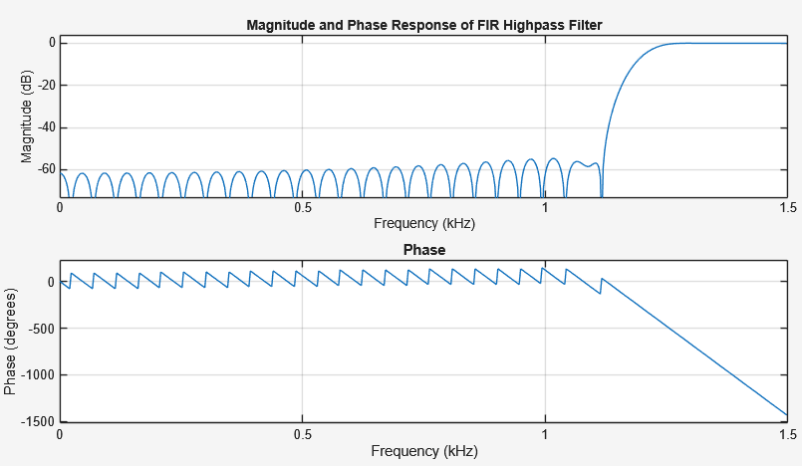  FIR Highpass Filter This program is the inverse of the previous one. By adding the 'high' flag to the fir1 command, the filter coefficients are calculated to attenuate low frequencies and pass high frequencies. With a cutoff of 1200 Hz, the magnitude response on the plot will show attenuation (low dB values) for frequencies from 0 to 1200 Hz, and then rise to 0 dB (unity gain) for frequencies up to the Nyquist limit. This demonstrates how easily FIR filters can be reconfigured simply by changing a parameter.
8.3 Run program 8_3 and use the following frequency:  Passband range of frequency = [300 600] ; sampling frequency = 1500 | 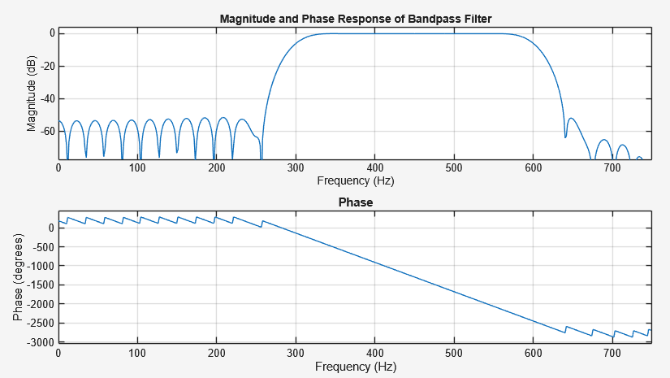  FIR Bandpass Filter Here, the fir1 function is provided with a two-element vector for the frequency range ([300 600] Hz) rather than a single scalar. MATLAB interprets this vector as the start and stop points of a passband. The resulting plot shows a "bell" or "box" shape in the magnitude response, where signals between 300 Hz and 600 Hz are preserved (near 0 dB), while frequencies below 300 Hz and above 600 Hz are suppressed. This type of filter is essential for isolating specific signals of interest, like a voice channel.
8.4 Run program 8_4 and use the following frequency:  cutoff frequency = [500 1000] ; sampling frequency = 3000 | 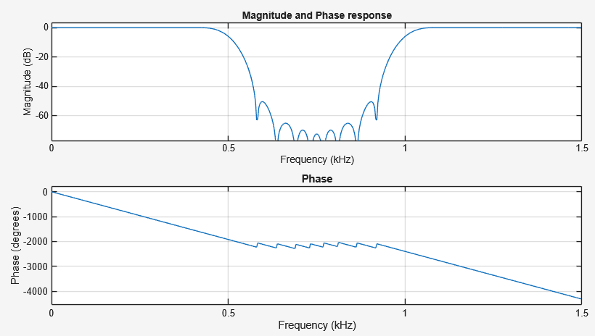  FIR Bandstop Filter This activity demonstrates the "notch" or rejection capability of FIR filters. By using the 'stop' flag with a frequency vector, the filter does the opposite of the bandpass: it passes everything except the specified range. The magnitude plot will show a deep "valley" between 500 Hz and 1000 Hz where the signal is heavily attenuated, while the low frequencies (0–500 Hz) and high frequencies (1000+ Hz) remain at 0 dB. This is commonly used to remove specific interference, such as 60 Hz power line hum.
8.5 Run program 8_5 and use the following frequency:  cutoff frequency = 1200 ; sampling frequency = 3000 | 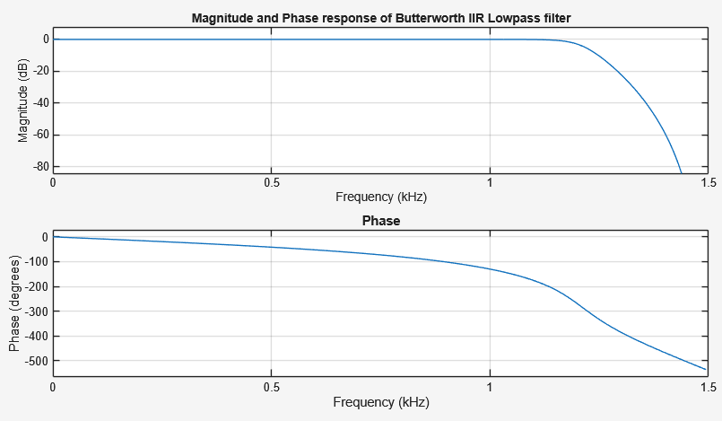  IIR Butterworth Lowpass Filter This activity introduces Recursive (IIR) filters using the Butterworth method. The Butterworth design is famous for being "maximally flat" in the passband, meaning it has no ripples or fluctuations in gain before the cutoff frequency. The generated plot shows a very smooth curve that rolls off monotonically after 1200 Hz. While it doesn't transition as sharply as Chebyshev filters, its advantage is that it doesn't distort the amplitude of the signals in the passband, making it ideal for audio applications.
8.6 Run program 8_6 and use the following frequency:  cutoff frequency = 1200 ; sampling frequency = 3000 | 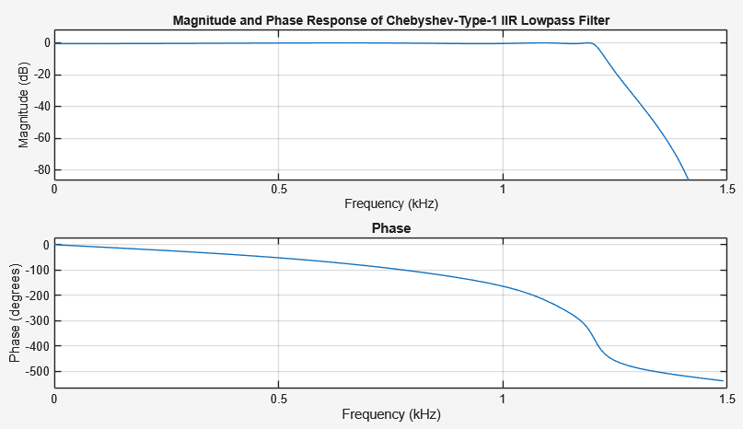  IIR Chebyshev Type I Lowpass Filter This program designs a filter that prioritizes a sharper transition (steeper roll-off) at the expense of "ripples" in the passband. The parameter rp = 0.5 specifies that we allow 0.5 dB of fluctuation in the allowed frequencies. The magnitude plot will look wavy or bumpy before the cutoff frequency of 1200 Hz, but it will drop down to the stopband much faster than the Butterworth filter. This demonstrates the engineering trade-off between signal purity (flatness) and selectivity (sharpness).
8.7 Run program 8_7 and use the following frequency:  cutoff frequency = 1200 ; sampling frequency = 3000 | 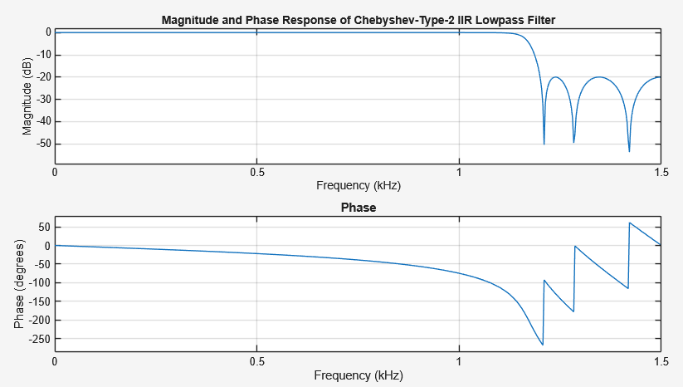  IIR Chebyshev Type II Lowpass Filter The Chebyshev Type II filter flips the trade-off found in Type I. Instead of having ripples in the passband, it keeps the passband flat (like Butterworth) but allows ripples in the stopband (the attenuated region). The code sets R = 20, meaning the stopband will not just drop to negative infinity but will bounce below -20 dB. The plot shows a smooth line up to the cutoff, followed by an immediate drop and then oscillatory behavior in the high frequencies. This is useful when passband accuracy is critical, but we still need a sharper cutoff than Butterworth.
8.8. Write a MATLAB program to design a Highpass IIR filter using Butterworth, Chebyshev Type_1, and Chebyshev Type_2 methods. Use your own values. Compare the Magnitude and Phase Response of the three by plotting them on the same plot. | % Program 8.8: Comparison of Highpass IIR Filters  % Methods: Butterworth, Chebyshev Type I, Chebyshev Type II  clf; clear all; close all;  % --- User Defined Values ---  N = 512; % Number of frequency points  n = 6; % Filter Order  fs = 3000; % Sampling Frequency (Hz)  fc = 1000; % Cutoff Frequency (Hz)  Rp = 1; % Passband Ripple (dB) for Chebyshev Type I  Rs = 40; % Stopband Attenuation (dB) for Chebyshev Type II  % Normalized Frequency  Wc = 2 * fc / fs;  % --- Filter Design ---  % 1. Butterworth Highpass  [b_but, a_but] = butter(n, Wc, 'high');  [h_but, w] = freqz(b_but, a_but, N, fs);  % 2. Chebyshev Type I Highpass  [b_c1, a_c1] = cheby1(n, Rp, Wc, 'high');  [h_c1, ~] = freqz(b_c1, a_c1, N, fs);  % 3. Chebyshev Type II Highpass  [b_c2, a_c2] = cheby2(n, Rs, Wc, 'high');  [h_c2, ~] = freqz(b_c2, a_c2, N, fs);  % --- Plotting Magnitude Response ---  figure(1);  subplot(2,1,1);  plot(w, 20*log10(abs(h_but)), 'b', 'LineWidth', 1.5); hold on;  plot(w, 20*log10(abs(h_c1)), 'r--', 'LineWidth', 1.5);  plot(w, 20*log10(abs(h_c2)), 'g-.', 'LineWidth', 1.5);  grid on;  title('Magnitude Response of Highpass IIR Filters');  xlabel('Frequency (Hz)'); ylabel('Magnitude (dB)');  legend('Butterworth', 'Chebyshev Type I', 'Chebyshev Type II');  ylim([-100 10]);  % --- Plotting Phase Response ---  subplot(2,1,2);  plot(w, angle(h_but), 'b', 'LineWidth', 1.5); hold on;  plot(w, angle(h_c1), 'r--', 'LineWidth', 1.5);  plot(w, angle(h_c2), 'g-.', 'LineWidth', 1.5);  grid on;  title('Phase Response of Highpass IIR Filters');  xlabel('Frequency (Hz)'); ylabel('Phase (radians)');  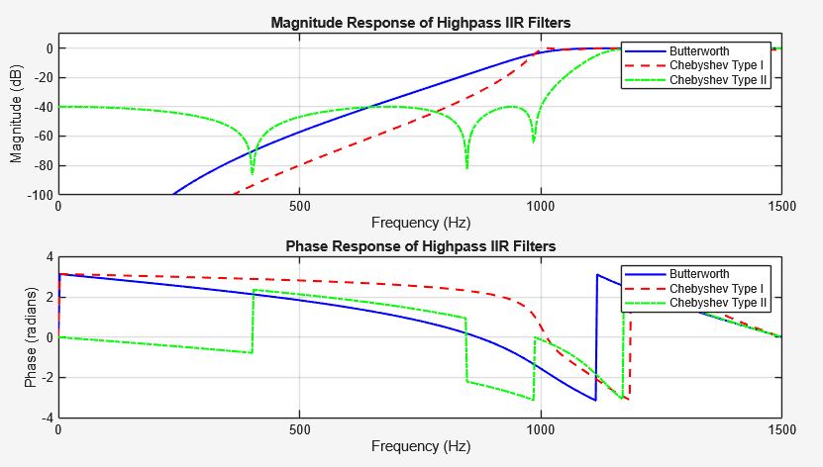  legend('Butterworth', 'Chebyshev Type I', 'Chebyshev Type II');  This code overlays the three IIR methods (Butterworth, Chebyshev I, and Chebyshev II) for a Highpass design. The plot vividly illustrates the differences in "steepness." You will see that the Chebyshev Type I (red dashed line) rises the fastest from attenuation to passband but wiggles once it gets there. The Butterworth (blue line) rises more slowly but is perfectly smooth. The Chebyshev Type II (green dot-dash) is smooth in the passband but wiggles in the lower, attenuated frequencies. This visual comparison helps you decide which filter to use based on whether you care more about a sharp cutoff or a smooth signal.
8.9. Write a MATLAB program to design a Bandpass IIR filter using Butterworth, Chebyshev Type_1, and Chebyshev Type_2 methods. Use your own values. Compare the Magnitude and Phase Response of the three by plotting them on the same plot. | % Program 8.9: Comparison of Bandpass IIR Filters  % Methods: Butterworth, Chebyshev Type I, Chebyshev Type II  clf; clear all; close all;  % --- User Defined Values ---  N = 512;  n = 6; % Order  fs = 3000; % Sampling Frequency  pass_range = [300 600]; % Passband Range (Hz)  Rp = 1; % Passband Ripple (dB)  Rs = 40; % Stopband Attenuation (dB)  % Normalized Frequency Vector  Wn = 2 * pass_range / fs;  % --- Filter Design ---  % 1. Butterworth Bandpass  % Note: 'bandpass' is the default if Wn has 2 elements, but we make it explicit  [b_but, a_but] = butter(n, Wn, 'bandpass');  [h_but, w] = freqz(b_but, a_but, N, fs);  % 2. Chebyshev Type I Bandpass  [b_c1, a_c1] = cheby1(n, Rp, Wn, 'bandpass');  [h_c1, ~] = freqz(b_c1, a_c1, N, fs);  % 3. Chebyshev Type II Bandpass  [b_c2, a_c2] = cheby2(n, Rs, Wn, 'bandpass');  [h_c2, ~] = freqz(b_c2, a_c2, N, fs);  % --- Plotting Magnitude Response ---  figure(2);  subplot(2,1,1);  plot(w, 20*log10(abs(h_but)), 'b', 'LineWidth', 1.5); hold on;  plot(w, 20*log10(abs(h_c1)), 'r--', 'LineWidth', 1.5);  plot(w, 20*log10(abs(h_c2)), 'g-.', 'LineWidth', 1.5);  grid on;  title('Magnitude Response of Bandpass IIR Filters');  xlabel('Frequency (Hz)'); ylabel('Magnitude (dB)');  legend('Butterworth', 'Chebyshev Type I', 'Chebyshev Type II');  ylim([-100 10]);  % --- Plotting Phase Response ---  subplot(2,1,2);  plot(w, angle(h_but), 'b', 'LineWidth', 1.5); hold on;  plot(w, angle(h_c1), 'r--', 'LineWidth', 1.5);  plot(w, angle(h_c2), 'g-.', 'LineWidth', 1.5);  grid on;  title('Phase Response of Bandpass IIR Filters');  xlabel('Frequency (Hz)'); ylabel('Phase (radians)');  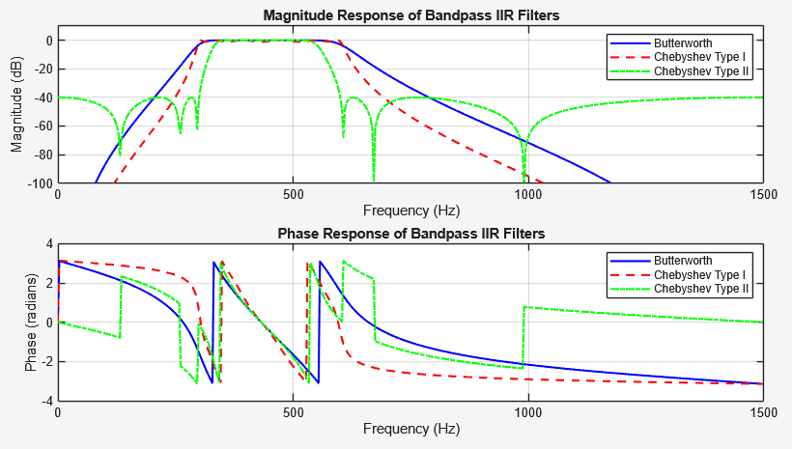  legend('Butterworth', 'Chebyshev Type I', 'Chebyshev Type II');  In this bandpass comparison, the differences become even more apparent at the "corners" of the frequency band (300 Hz and 600 Hz). The Chebyshev filters will show much "squarer" corners, meaning they separate the desired frequencies more strictly than the Butterworth filter, which will look more rounded or bell-shaped. However, the Phase Response subplot usually reveals that the Butterworth filter has a more linear phase shift, which is better for maintaining the timing of the signal, whereas the Chebyshev filters introduce more phase distortion near the band edges.
8.10. Write a MATLAB program to design a Highstop IIR filter using Butterworth, Chebyshev Type_1, and Chebyshev Type_2 methods. Use your own values. Compare the Magnitude and Phase Response of the three by plotting them on the same plot. | % Program 8.10: Comparison of Bandstop (Highstop) IIR Filters  % Methods: Butterworth, Chebyshev Type I, Chebyshev Type II  clf; clear all; close all;  % --- User Defined Values ---  N = 512;  n = 6; % Order  fs = 3000; % Sampling Frequency  stop_range = [500 1000]; % Stopband Range (Hz)  Rp = 1; % Passband Ripple (dB)  Rs = 40; % Stopband Attenuation (dB)  % Normalized Frequency Vector  Wn = 2 * stop_range / fs;  % --- Filter Design ---  % 1. Butterworth Bandstop  [b_but, a_but] = butter(n, Wn, 'stop');  [h_but, w] = freqz(b_but, a_but, N, fs);  % 2. Chebyshev Type I Bandstop  [b_c1, a_c1] = cheby1(n, Rp, Wn, 'stop');  [h_c1, ~] = freqz(b_c1, a_c1, N, fs);  % 3. Chebyshev Type II Bandstop  [b_c2, a_c2] = cheby2(n, Rs, Wn, 'stop');  [h_c2, ~] = freqz(b_c2, a_c2, N, fs);  % --- Plotting Magnitude Response ---  figure(3);  subplot(2,1,1);  plot(w, 20*log10(abs(h_but)), 'b', 'LineWidth', 1.5); hold on;  plot(w, 20*log10(abs(h_c1)), 'r--', 'LineWidth', 1.5);  plot(w, 20*log10(abs(h_c2)), 'g-.', 'LineWidth', 1.5);  grid on;  title('Magnitude Response of Bandstop IIR Filters');  xlabel('Frequency (Hz)'); ylabel('Magnitude (dB)');  legend('Butterworth', 'Chebyshev Type I', 'Chebyshev Type II');  ylim([-100 10]);  % --- Plotting Phase Response ---  subplot(2,1,2);  plot(w, angle(h_but), 'b', 'LineWidth', 1.5); hold on;  plot(w, angle(h_c1), 'r--', 'LineWidth', 1.5);  plot(w, angle(h_c2), 'g-.', 'LineWidth', 1.5);  grid on;  title('Phase Response of Bandstop IIR Filters');  xlabel('Frequency (Hz)'); ylabel('Phase (radians)');  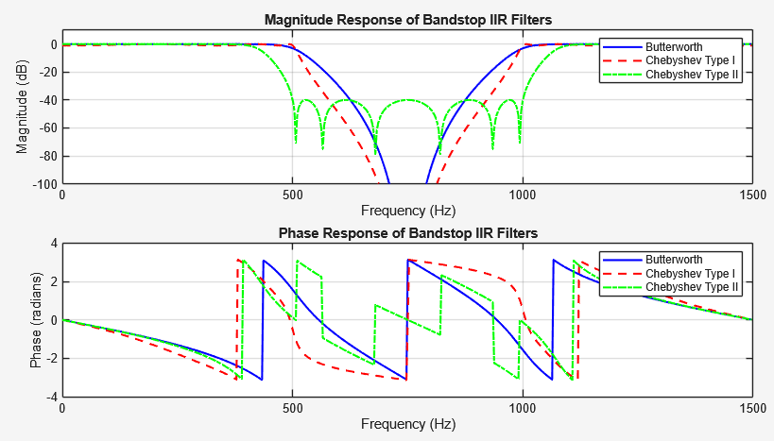  legend('Butterworth', 'Chebyshev Type I', 'Chebyshev Type II');  This final exercise compares how the three methods reject a specific chunk of frequencies (500-1000 Hz). The plot reveals how deep and wide the rejection "valley" is for each type. The Chebyshev Type I usually provides the sharpest descent into the valley, ensuring that frequencies right next to 500 Hz or 1000 Hz are filtered strictly. The Butterworth filter will have a wider transition, meaning it might accidentally attenuate some frequencies slightly outside the target range (e.g., 450 Hz or 1050 Hz) because its slope is more gradual.

- Conclusion
Activity 8 successfully demonstrated the fundamental principles and practical implementation of digital filter design using MATLAB. By exploring both Finite Impulse Response (FIR) and Infinite Impulse Response (IIR) filters, we established that while FIR filters offer inherent stability and linear phase characteristics, IIR filters provide a more computationally efficient solution for achieving sharp cutoffs with lower filter orders. Through the comparative exercises (8.8 to 8.10), we observed distinct trade-offs among the standard IIR approximation methods: the Butterworth filter delivers the smoothest response with a maximally flat passband but a slower roll-off; the Chebyshev Type I filter achieves a steeper transition at the cost of passband ripples; and the Chebyshev Type II filter offers a sharp cutoff with a flat passband but introduces ripples in the stopband. This activity highlights that there is no single "perfect" filter; rather, the choice depends on specific application requirements, such as the need for phase linearity, signal purity, or rapid attenuation of unwanted frequencies. MATLAB's built-in functions proved to be powerful tools in visualizing these characteristics, allowing for rapid prototyping and analysis of filter performance.

